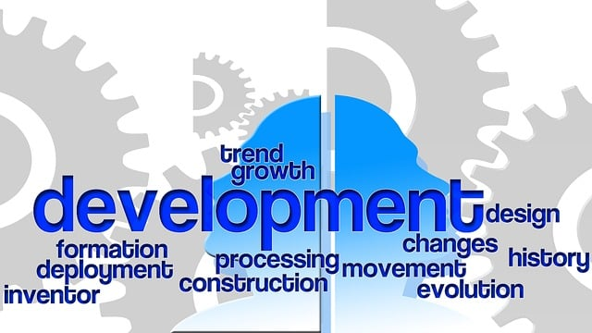



PARTNER WITH HRWAVERIDER TO ASSIST YOUR HUMAN RESOURCES TEAM

WITH COMPLIANCE